- Prob 1: https://github.com/miunthphuong/MPP/tree/main/Assigment/Lab5/Lab%205%20-%20Code/Prob1
- Prob 2: https://github.com/miunthphuong/MPP/tree/main/Assigment/Lab5/Lab%205%20-%20Code/Prob2
- Prob 3: https://github.com/miunthphuong/MPP/tree/main/Assigment/Lab5/Lab%205%20-%20Code/Prob3
Class diagram:

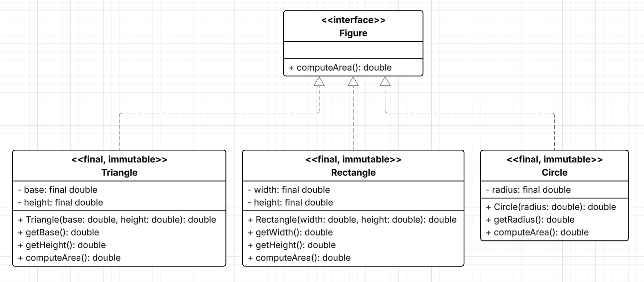

- Prob 4: https://github.com/miunthphuong/MPP/tree/main/Assigment/Lab5/Lab%205%20-%20Code/Prob4

